|  |  |
| --- | --- |
| Game Design Document  ‘My Family is Dead and so am I.’ | Target Platform: PC Target Audience: Teens/Young Adults Target Rating: 16+ Approx. Shipping Date: Halloween 2021  Cillian Drohan & Denis Moskalenko  CA3 |

Story and Gameplay

**STORY:** Alice is a young girl that lives a happy life with her family, but that all changes when an evil spirit called Elvira decides to make them her prey. Elvira kills Alice and her entire family, wanting to harvest their souls. Elvira lures the spirits of the family members one by one to a magic circle which will trap them in a wooden box.

Alice wakes up in the attic of her family’s home with no recollection of her death. The house looks rundown. She wakes with the wooden box next to her, which rumbles and makes sounds. She takes the box and discovers her family’s bodies and her own and meets Elvira who taunts her.

Alice scared and alone tries to make her way out of the house but spirits in the box keeps escaping briefly and hindering her progress. Some other spirits try to guide her along the way to circumnavigate the ruined house.

Alice eventually winds up in the living room where Elvira is waiting to ambush her. The magic circle to trap Alice is set up and ready to go. Alice must fight so she does not end up trapped like the rest of her family.

**GAMEPLAY:** The player must navigate the creepy house solving puzzles and exploring to progress and get to the bottom floor where they will confront Elvira. The player may need to gather some items and inspect their surrounding to complete puzzles and progress the story.

The player will experience some scares as they progress towards Elvira, as finish some creepy tasks to finish the game. The overall gameplay creates an interesting and scary experience as the player navigate the haunted mansion.

The player may be helped or hindered by random ghosts/spirits appearing. This will happen by random chance. The players actions and choices throughout the game will alter the ending so the experience will be unique for every player.

Game Flow

The player will need to inspect their surrounding to progress. Inspecting items and surroundings may give the player: story info, hints on how to progress, or a usable item required to progress. As the player progress with the puzzles they will get info on the story but by inspecting the surrounding they can get a more in-depth look at the story or they can skip these and just get the barebones story. The extra pieces of story will come in as achievement that the player can look back on later and get a more detailed version of the story similar to the game ‘Until Dawn’.

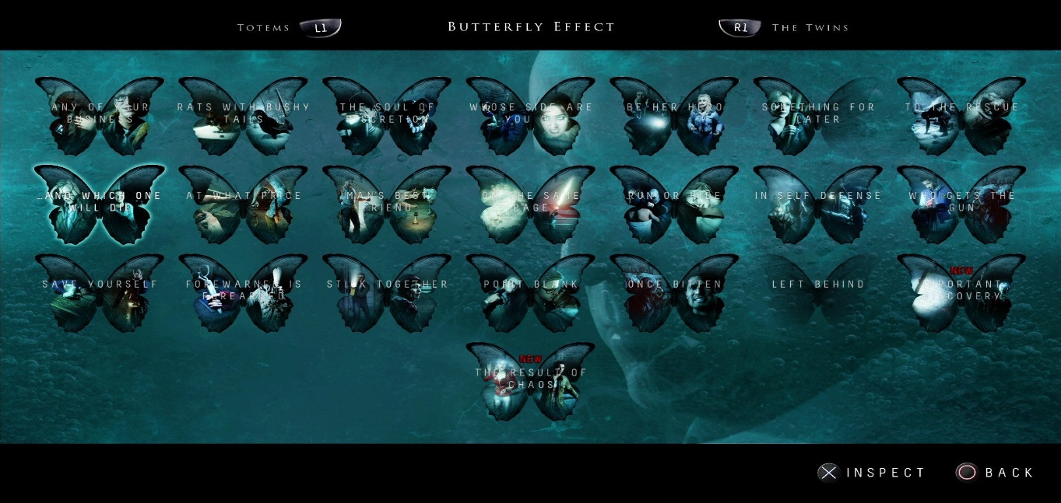

Characters and Controls

**CHARACTER:** Alice is the character the playable character. She is a young girl, wearing a dress and sandals with long hair. She appears in black and white as a ghost. When the player finds Alice’s body, she has blonde hair, a white dress, brown sandals and is very pale/grey looking. The character is not customisable.

**CONTROLS:** wasd controls (**w** = forward, **s** = backwards, **a** = left, **d** = right) **e** = inspect/use

**right shift** = run **tab** = to-do list **f** = inventory

*(While in inventory)* **right click** = select/hold **esc** = menu/options

Main Gameplay Concepts and Platform Specific Features

**MAIN GENRES:** horror, puzzle, visual novel.

**BROKEN UP BY:** levels

The main unique concept is the interactions with the ghost within the box. There is a random chance to summon a good ghost or a bad ghost. Good ghosts help the player progress by acting as guides or illuminating areas, etc. Bad ghosts hinder progress my messing with the environment or stealing the players items, etc. In this way every player will have a unique experience while playing the game depending on their luck throughout their gameplay.

Game World

The world is inspired by a number of games, including but not limited to: Until Dawn, Phasmophobia, Slender, Danganronpa.

The game takes place inside of Alice’s house. The house looks a bit run down and dull, and its night-time making the house dark. The house consists of an attic, and a first and second floor.

Every floor is dark, dusty and creepy. Every floor will have its own scary factor. The levels will progressively get creepier as the player gets closer to facing Elvira.

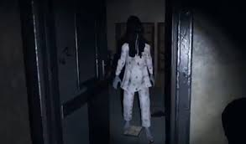

Interface

The player will navigate the game with a simple menu shown by the flow chart below. The atmosphere provoked will be tense, dark and spooky. The background image will be a dark black and white image of the house and the music will be quiet and spooky to reflect the image. An ‘Extras’ tab will be unlocked upon completion of a player first run of the game. This will appear below the ‘Load Game’ tab.

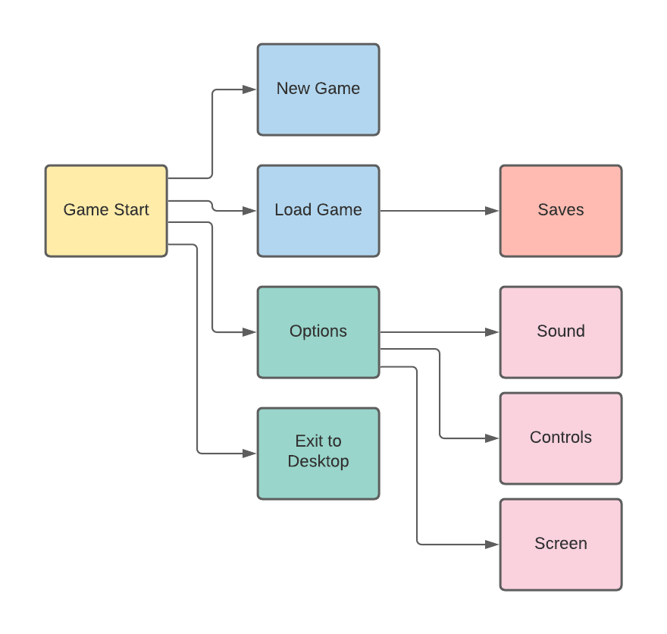

Mechanics and Power-Ups

The player will be able to pickup items to use them. The player can select an item to use by going into the inventory and clicking on the item. The player can then press ‘e’ to use the item on something in the environment. This may fail as the item may not be compatible with what the player is interacting with and an appropriate message will pop-up to notify the player. This mechanic is required to complete puzzles and progress.

Enemies and Bosses

**ENEMIES:** The enemies are spirits that escape from the box. They will not attack the player directly but will impede their progress by stealing items and hiding them, turning off lights, etc. A ghost has a percentage chance of spawning and what the ghost does is decided upon appearing. What the ghost can do is determine by: the level, items in players inventory, puzzles completed, player’s interaction with surroundings.

**BOSS:** Elvira is the final boss. The player must interact with the environment and make use of the equipment they have gather thus-far to defeat Elvira.

Cutscenes, Bonus Material, and Comps

Cutscenes will be played at the beginning and at the end of the game. The first showing the box and Alice in the attic. The last showing Alice ascending and the box being left in the house. This will be done using puppet show.

Players will be able to unlock extra material about the story by inspect their environment and completing the story. Play will be able to view these by going into ‘extras’ in the start menu.

Our main competition will be any game that features paranormal activity and is story driven with multiple outcomes.

Appendix/Playtest

1. How did you find the game experience overall?
2. Did you encounter any difficulties while playing?
3. Were there any parts that you found boring or uninteresting?
4. What was the most frustrating part of your experience?
5. What was the favourite part of the game?
6. What would you change about the game?
7. How would you describe this game to anyone who asked about it?

Player 1:

Potential bias

Enjoyed the speed aspect of the game in certain areas, enjoyed levels with speed integrated into them more.

Was slightly confusing in certain areas.

Second level should’ve been more interactive player didn’t engage enough.

Didn’t find it frustrating.

The last level where trying to click the correct one while the options flashed.

Give it a different ending.

Horror, mystery game.

Overall rating:8/10

Player 2:

Potential bias

Found the game inventive and intriguing. Enjoyed the option to have multiple paths.

Found a dead end when inspecting the father.

Found nothing boring. Would have loved to hear more about the backstory and ambitions of the character.

Found it frustrating to grab the key from Elvira.

Liked exploring the rooms and the comments Alice made. Enjoyed having the perspective of a child rather than a narration.

Some grammatical errors. Elvira sounds too cheesy, not threatening enough sounds like English is second language. Player also didn’t realise on the second ending you had to wait for the candle to show up. Potential fix: Lessen the time the candle doesn’t show up.

Would describe it as an interactive choice game with a paranormal setting.

Overall rating:8/10

Player 3:

Potential bias

Considers Chapter 1 to be the best written. Second chapter seems to be lacking. Found chapter 4 fun.

No difficulties but found the two keys having no distinction confusing.

Not at all. Found the time related events fun with some being a little quick. First link disappearance is unexpected leading to the other option being chosen.

Finding the dolls when they were taken away.

Enjoyed the ending with the time events.

Dead ends. Grammatical mistakes. Some endings not making sense. Change the name of the cursed dolls into an alliteration.

“Its like The Dark Knight except with Ghosts, Death and adventure, instead of a man wiht money and another mental health issues”

Overall rating:8/10

Player 4:

Potential bias

Enjoyed the experience.

Found it hard to find the dolls.

Everything was interesting.

Found it frustrating when wasn’t able to throw object at Elvira. Didn’t realise you need to wait. Potential fix: Lessen the time the candle doesn’t show up.

All of it.

Grammatical errors.

/no comment/

Overall rating:7/10

Player 5:

Potential bias

Enjoyed the game. Found it easy to understand. Found decisions were clear cut and there were plenty of choices also found the functionality to be good. Didn’t encounter any errors or bugs so found the experience to be good.

Found the game easy to understand from start to finish so didn’t encounter any difficulties.

The game kept interest due to its length. Enjoyed the game being broken into chapters so that you could leave and pick up the game without having to restart it. Enjoyed the option to explore.

Didn’t find anything frustrating.

Favourite part of the game was the variety of choices given in almost every part of the game.

Would add images into the game to feel more immersed.

“If I was asked to describe this game to someone it would be a fantasy/RPG game where you get to make your own choices and decide your characters fate, the game itself is the perfect length with a good main character and a great story to keep you entertained through all four chapters.”

Overall rating:8.5

Overall Review:

Most of the players found the game enjoyable. None of the players found the game too difficult and the challenges entertaining.

The game still contains some minor bugs and dead ends that weren’t noticed during the development. The game also includes a variety of grammatical errors and not enough backstory. Minor changes are needed to the time spent waiting for the candle to show up due to players subconsciously thinking they didn’t find an item.